 | 7.1.27 Editors - 3D Viewport - Header - Grease Pencil - Edit mode - Grease Pencil menu
Table of content
Detailed table of content 1
Edit Mode - Grease Pencil Menu 5
Transform submenu 5
To Sphere 5
Shear 6
Bend 7
Push/Pull 7
Radius 8
Mirror submenu 10
Interactive Mirror 10
X Global, Y Global etc. 10
Snap submenu 10
Snap 10
Active Layer 11
New Layer 11
Layers 11
Animation 11
Insert Blank Key frame ( Active Layer ) 11
Insert Blank Key frame ( All Layers ) 11
Last Operator Insert Blank Frame 11
Duplicate Active Key frame ( Active Layer ) 12
Duplicate Active Key frame ( All Layers ) 12
Last Operator Insert Blank Frame 12
Delete Active Key frame ( Active Layer ) 12
Delete Active Key frame ( All Layers ) 12
Single Operators 12
Interpolate Sequence 12
Duplicate 12
Split 13
Copy 13
Paste 14
Paste by Layer 14
Dissolve 14
Delete 14
Cleanup sub menu 15
Show / Hide 16
Outline 17
Separate sub menu 17

Detailed table of content
Detailed table of content
Detailed table of content 1
Edit Mode - Grease Pencil Menu 5
Transform submenu 5
To Sphere 5
Last Operator To Sphere 5
Factor 5
Mirror Editing 5
Proportional Editing 5
Proportional editing 5
Proportional Falloff 5
Proportional Size 5
Connected 6
Projected(2D) 6
Shear 6
Last Operator Shear 6
Offset 6
Axis 6
Axis Ortho 6
Orientation 6
Mirror Editing 6
Proportional editing 6
Proportional Falloff 6
Proportional Size 7
Connected 7
Projected(2D) 7
Bend 7
Push/Pull 7
Last Operator Push/Pull 7
Distance 7
Mirror Editing 7
Proportional editing 7
Proportional Falloff 7
Proportional Size 7
Connected 7
Projected(2D) 7
Radius 8
Last Operator Transform 8
Values 8
Axis 8
Orientation 8
Mirror Editing 8
Proportional editing 8
Proportional Falloff 8
Proportional Size 8
Connected 8
Projected(2D) 8
Opacity 9
Last Operator Transform 9
Values 9
Axis 9
Orientation 9
Mirror Editing 9
Proportional editing 9
Proportional Falloff 9
Proportional Size 9
Connected 9
Projected(2D) 9
Mirror submenu 10
Interactive Mirror 10
X Global, Y Global etc. 10
Last Operator Mirror 10
Orientation 10
Constraint Axis 10
Snap submenu 10
Snap 10
Last operator Snap Selection to Cursor 11
Offset 11
Rotation 11
Active Layer 11
New Layer 11
Layers 11
Animation 11
Insert Blank Key frame ( Active Layer ) 11
Insert Blank Key frame ( All Layers ) 11
Last Operator Insert Blank Frame 11
All Layers 11
Duplicate Active Key frame ( Active Layer ) 12
Duplicate Active Key frame ( All Layers ) 12
Last Operator Insert Blank Frame 12
Mode 12
Delete Active Key frame ( Active Layer ) 12
Delete Active Key frame ( All Layers ) 12
Single Operators 12
Interpolate Sequence 12
Duplicate 12
Last Operator Duplicate 13
Move X , Y , Z 13
Orientation 13
Mirror Editing 13
Proportional editing 13
Proportional Falloff 13
Proportional Size 13
Connected 13
Projected(2D) 13
Split 13
Copy 13
Paste 14
Paste by Layer 14
Last operator Paste Strokes 14
Type 14
Dissolve 14
Dissolve 14
Dissolve Between 14
Dissolve Unselect 14
Last Operator Dissolve 14
Type 14
Delete 14
Delete 14
Delete Active Key frame(Active Layer) 14
Delete Active Key frame(All Layers) 15
Cleanup sub menu 15
Clean Loose Points 15
Last Operator Clean Loose Points 15
Limit 15
Delete Duplicated Frames 15
Last Operator Clean Duplicated Frames 15
Type 15
Merge by Distance 15
Last Operator Merge by Distance 15
Threshold 15
Unselected 15
Re project Strokes 16
Re project Strokes menu 16
Last Operator Re project Strokes 16
Projection Type 16
Remove Fill Guides 16
Last Operator Remove Fill Guides 16
Mode 16
Show / Hide 16
Show Hidden 16
Hide Selected 16
Last Operator Hide Selected 16
Unselected 16
Hide Unselected 17
Outline 17
Last Operator Outline 17
Projection mode 17
Radius 17
Offset Factor 17
Corner Subdivision 17
Separate sub menu 17
Selected Points 17
Selected Strokes 17
Active Layer 17
Last Operator Separate Strokes 17
Mode 17
Active Layer 17
Selected Strokes 18
Selected Points 18

Edit Mode - Grease Pencil Menu

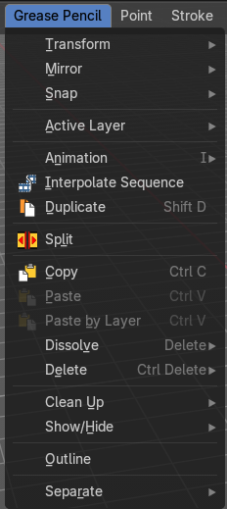

Transform submenu

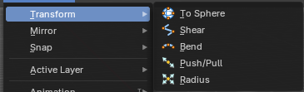

To Sphere
Transforms the selected geometry into a sphere shape.

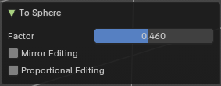
Last Operator To Sphere

Factor
The transform factor.

Mirror Editing
Edit mirror geometry too.

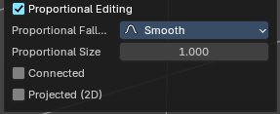
Proportional Editing

Proportional editing
Enables proportional editing. Activating proportional editing reveals further settings.

Proportional Falloff
Adjust the falloff methods.

Proportional Size
See and adjust the falloff radius.

Connected
The proportional falloff gets calculated for connected parts only.

Projected(2D)
The proportional falloff gets calculated in the screen space. Depth doesn't play a role. When it's in the radius, then it gets calculated.

Shear
Shear shears the selection.
In Object mode this tools requires to have more than one object selected.
The shear tool works along a imaginary 2d plane. The shear axis controls if the items are sheared along the x or the y axes of this plane. This is the plane along which the transformation happens. You can shear along the x or the y axis of this plane.
To make things even more complicated, the orientation of this imaginary plane is defined by the Axis and Axis Ortho items below.

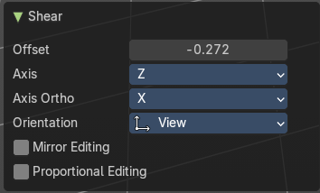
Last Operator Shear

Offset
Adjust an offset.

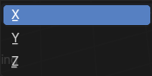
Axis
Defines one axis of the imaginary shear axis plane.

Axis Ortho
Defines the other axis of the imaginary shear axis plane.

Orientation
Choose the orientation for the shear action.

Mirror Editing
Enable mirror editing.

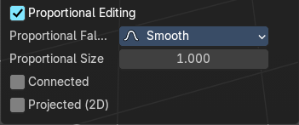
Proportional editing
Enables proportional editing. Activating proportional editing reveals further settings.

Proportional Falloff
Adjust the falloff methods.

Proportional Size
See and adjust the falloff radius.

Connected
The proportional falloff gets calculated for connected parts only.

Projected(2D)
The proportional falloff gets calculated in the screen space. Depth doesn't play a role. When it's in the radius, then it gets calculated.

Bend
Bends the selection.

Push/Pull
It pushes or pulls the object positions relative to the center of the selection.
In Object mode this tool requires to have more than one object selected.

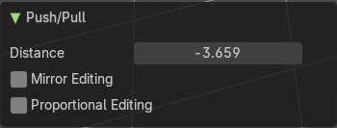
Last Operator Push/Pull

Distance
Adjust the distance of influence of the tool.

Mirror Editing
Enable mirror editing.

Proportional editing
Enables proportional editing. Activating proportional editing reveals further settings.

Proportional Falloff
Adjust the falloff methods.

Proportional Size
See and adjust the falloff radius.

Connected
The proportional falloff gets calculated for connected parts only.

Projected(2D)
The proportional falloff gets calculated in the screen space. Depth doesn't play a role. When it's in the radius, then it gets calculated.

Radius
Scales the selected geometry of a curve along its normals. Grease pencil is under the hood a curve. Transform orientation and Pivot point gets ignored.
A positive value pushes the vertices outwards. A negative value pushes the vertices inwards.

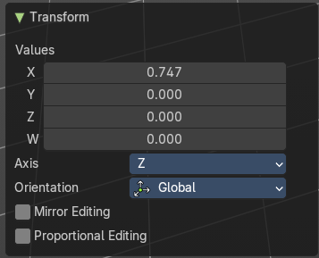
Last Operator Transform

Values
The transform values.

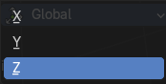
Axis
The transform axis.

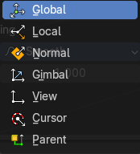
Orientation
Choose the orientation.

Mirror Editing
Enable Mirror Editing.

Proportional editing
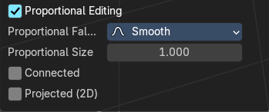
Enables proportional editing. Activating proportional editing reveals further settings.

Proportional Falloff
Adjust the falloff methods.

Proportional Size
See and adjust the falloff radius.

Connected
The proportional falloff gets calculated for connected parts only.

Projected(2D)
The proportional falloff gets calculated in the screen space. Depth doesn't play a role. When it's in the radius, then it gets calculated.

Opacity
Changes the transparency of selected Grease Pencil vertices. Higher values = more opaque; lower values = more transparent. This is useful for shading, layering, or fade effects in drawings.
To use, activate then drag left or right to change the stroke opacity.
Note: This does not affect fill opacity, only stroke.

Last Operator Transform

Values
The transform values.

Axis
The transform axis.

Orientation
Choose the orientation.

Mirror Editing
Enable Mirror Editing.

Proportional editing
Enables proportional editing. Activating proportional editing reveals further settings.

Proportional Falloff
Adjust the falloff methods.

Proportional Size
See and adjust the falloff radius.

Connected
The proportional falloff gets calculated for connected parts only.

Projected(2D)
The proportional falloff gets calculated in the screen space. Depth doesn't play a role. When it's in the radius, then it gets calculated.

Mirror submenu

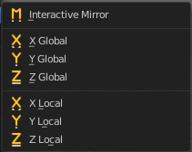
Mirror mirrors the selected geometry along the defined axis.

Interactive Mirror
Mirror by hotkeys. You activate the tool, type in x for x global for example, or x x for x local. And the selection gets mirrored

X Global, Y Global etc.
Mirrors the selection around the chosen axis.

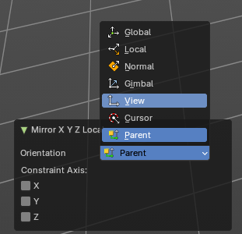
Last Operator Mirror
The Last Operator Mirror panel gives you tools to adjust the mirror action.


Orientation
Orientation is a drop-down box . Choose the type of orientation for the mirroring action.

Constraint Axis
Constraint Axis gives you again the possibility to define the mirror axis. You can choose more than one axis here.

Snap submenu

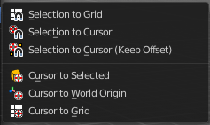
Snap
Choose several methods to snap one element to another. The menu items should be self explaining.

Last operator Snap Selection to Cursor
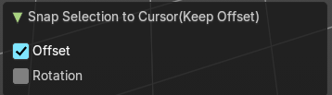
Some snap operations shows a last operation panel, some not.

Offset
If the selection should snap as a whole, or if each individual element of the selection should snap.

Rotation
If the selection should be rotated to match the cursor.

Active Layer

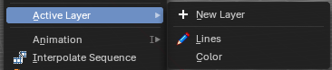
Set the active layer

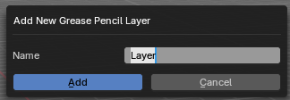
New Layer
Add a new greasepencil layer. A popup will appear where you can add the name.

Layers
The list of the available layers.

Animation

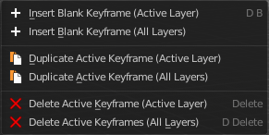
Insert Blank Key frame ( Active Layer )
Inserts a key frame into the active layer.

Insert Blank Key frame ( All Layers )
Inserts a key frame into all layers.

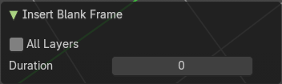
Last Operator Insert Blank Frame
Some snap operations shows a last operation panel, some not.

All Layers
Insert into active layer or into all layers.

Duplicate Active Key frame ( Active Layer )
Duplicates the active key frame in the active layer.

Duplicate Active Key frame ( All Layers )
Duplicates the active key frame in all layers.

Last Operator Insert Blank Frame
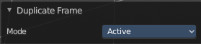
Some snap operations shows a last operation panel, some not.

Mode
Duplicate the active key frame in the active layer or in all layers.

Delete Active Key frame ( Active Layer )
Deletes the active key frame in the active layer.

Delete Active Key frame ( All Layers )
Deletes the active key frame in all layers

Single Operators

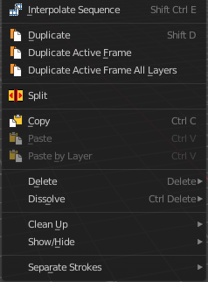
Interpolate Sequence
Interpolate strokes between the previous and next keyframe by adding multiple keyframes. When you are on a frame between two keyframes and click the sequence button, then a breakdown keyframe will be added on every frame between the previous and next keyframe.

Duplicate
Duplicates the current selection. This can be a single control point or a whole curve.
The copy sticks to the mouse until you release it. A Right click while moving will reset the position of the duplicate. The duplicated part will be part of the same object.
When you drag the duplicate around you will see the position values in the header.

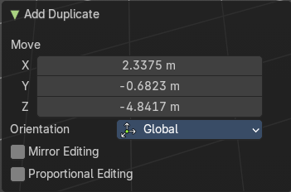
Last Operator Duplicate

Move X , Y , Z

Orientation
Choose the orientation.

Mirror Editing
Enable Mirror Editing.

Proportional editing
Enables proportional editing. Activating proportional editing reveals further settings.

Proportional Falloff
Adjust the falloff methods.

Proportional Size
See and adjust the falloff radius.

Connected
The proportional falloff gets calculated for connected parts only.

Projected(2D)
The proportional falloff gets calculated in the screen space. Depth doesn't play a role. When it's in the radius, then it gets calculated.

Split
Split selected points to a new stroke.

Copy
Copies the selection.

Paste
Pastes a copied selection to active layer. You can have more than one layer.

Paste by Layer
Pastes a copied selection to same, original layer. You can have more than one layer.

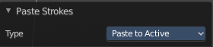
Last operator Paste Strokes

Type
Choose between the paste methods again.

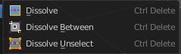
Dissolve
Dissolve is a union operation. Two edges becomes one edge by removing the vertice in between.

Dissolve
Dissolves the selection.

Dissolve Between
Dissolves the vertices between the selected vertices.

Dissolve Unselect
Dissolves the vertices that are not selected.

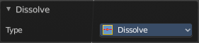
Last Operator Dissolve

Type
Choose how you want to dissolve.

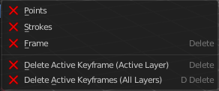
Delete

Delete
Delete selected stroke points.

Delete Active Key frame(Active Layer)
Deletes the active key frame in the current active layer.

Delete Active Key frame(All Layers)
Deletes the active key frame in all layers.

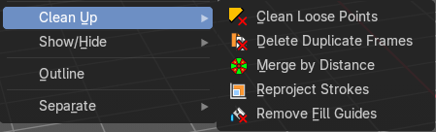
Cleanup sub menu

Clean Loose Points
Deletes not connected stroke geometry that is made of loose points.

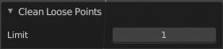
Last Operator Clean Loose Points

Limit
The number of vertices below which a stroke gets counted as a loose point.

Delete Duplicated Frames
Deletes all duplicated frames.

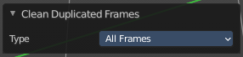
Last Operator Clean Duplicated Frames

Type
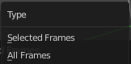
Delete just in the selected frames or in all frames.

Merge by Distance
Merge selected geometry that is in a specific range to each other.

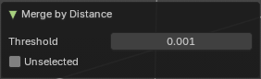
Last Operator Merge by Distance

Threshold
Delete just in the selected frames or in all frames.

Unselected
Also merge geometry by distance that is not selected but part of the stroke.

Re project Strokes
Re project the selected strokes onto a new plane from the current viewport. So that all strokes are on one plane.

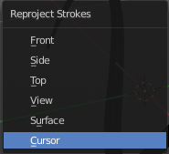
Re project Strokes menu
Using this tool opens a popup menu. Choose the projection type method.

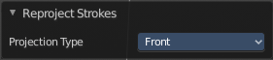
Last Operator Re project Strokes

Projection Type
A popup menu. Choose the projection type method.

Remove Fill Guides
In Draw mode with the fill tool you are able to draw so called fill guide with holding down the ALT key. They act as the boundary of the fill area. This tool removes these fill guides.

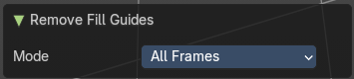
Last Operator Remove Fill Guides

Mode
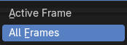
All frames or just the current frame.


Show / Hide

Show Hidden
Makes all curve geometry in the scene visible again.

Hide Selected
Hides the selected curve geometry.


Last Operator Hide Selected

Unselected
Hides the not selected curve geometry.

Hide Unselected
Hides the not selected curve geometry. The selected geometry stays visible.

Outline
Convert selected strokes to perimeter.

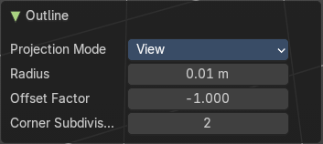
Last Operator Outline

Projection mode
Hides the not selected layers.

Radius
The radius.

Offset Factor
The offset factor.

Corner Subdivision
The corner subdivision resolution.

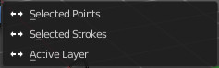
Separate sub menu
Separates the selection into a new grease pencil object.

Selected Points
Separate the selected points with its edges.

Selected Strokes
Separate the whole stroke of the current selection.

Active Layer
Separate all the strokes at the current active layer.

Last Operator Separate Strokes

Mode

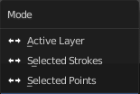
Active Layer
Separate all the strokes at the current active layer.

Selected Strokes
Separate the whole stroke of the current selection.

Selected Points
Separate the selected points with its edges.

